TASK 1 – HANGMAN GAME

Company : CODEALPHA

Name : Devangam Narayanaswamy Veena

College : Sri Venkateshwara College of Engineering

Branch : Information Technology(5th sem)

ID : CA/AU1/6113

Language : Python

# ⧫Objective :

The goal of this task is to craetae a simple text based Hangman Game where the player gusses a word one letter at a time.

# ⧫Key Concepts used :

• Random module

• While loop

• if else statements

• Srings

• Lists and Sets

# ⧫Steps :

1. Import the random module.
2. Define a list of 5 words( like fruits, names, colors.,etc ).
3. Select a random word from the list.
4. Initialize variable for guessed letters and number of wrong guesses.
5. Display underscore for each letter in the word.
6. Use while loop to:

(a) Ask the user for a letter.

(b)Check if the letter is valid and not guessed before.

(c)Update guessed letters and wrong guesses accordingly.

7) Display the word progress after each guess.

8) End the game when the word is suessed or the user runs out of attempts.

# ⧫Code :

import random # To pick a random word

# Step 1: Predefined list of words

words = ["python", "program", "hangman", "coding", "developer"]

# Step 2: Choose a random word

word = random.choice(words)

word_letters = set(word) # Letters to guess

guessed_letters = set() # Letters guessed

wrong_guesses = 0 # Wrong guess counter

max_guesses = 6 # Maximum wrong guesses

print("🎮 Welcome to Hangman!")

print("_ " * len(word)) # Show underscores for each letter

# Step 3: Game loop

while wrong_guesses < max_guesses and word_letters:

print(f"\nGuessed letters: {' '.join(sorted(guessed_letters))}")

print(f"Wrong guesses left: {max_guesses - wrong_guesses}")

# Show the word with guessed letters

display_word = [letter if letter in guessed_letters else '_' for letter in word]

print("Word: ", ' '.join(display_word))

# Step 4: Ask user for a guess

guess = input("Guess a letter: ").lower()

# Step 5: Validate input

if len(guess) != 1 or not guess.isalpha():

print("❌ Please enter a single alphabet letter.")

continue

# Step 6: Check if guessed before

if guess in guessed_letters:

print("⚠ You already guessed that letter.")

elif guess in word_letters:

print("✅ Good guess!")

guessed_letters.add(guess)

word_letters.remove(guess)

else:

print("❌ Wrong guess!")

wrong_guesses += 1

guessed_letters.add(guess)

# Step 7: End of game

if not word_letters:

print(f"\n🎉 Congratulations! You guessed the word: {word}")

else:

print(f"\n💀 Game Over! The word was: {word}")

# ⧫Sample Output :

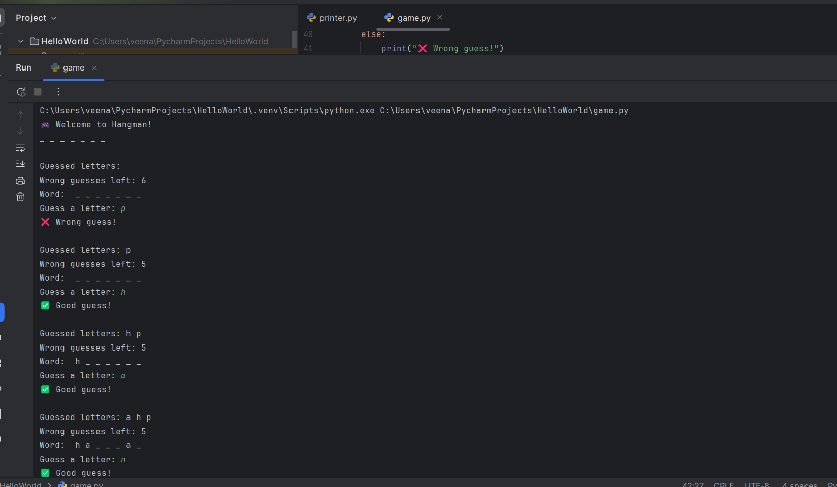

# ⧫Conclusion :

This program successfully implements a simple Hangman game using Python basic concepts such as loops, conditions, and random module.